ServoFlapOrnithopter 86-3-2&3 setting manual

New Servo Flap System by K.Kakuta

1 Bilateral Servo Flap between Max high point and Max low point

- change max flap point (throttle stick) and change Flapping frequency(5ch)

3 Change center of Flapping angle Horizontal (Ch1 aileron stick) and Vertical (Ch2 elevator stick)

4 Change flapping amplitude on each Servo (Ch4 rudder stick)

Increase flap amplitude of one servo and decrease flap amplitude of another servo

Setting : Set elevator and rudder and aileron stick Center-- 1500microsesond

Set 5Ch at any Volume or Slider or other switch

Set throttle stick at low max --1000 microsecond

5 wiring

1)PPM Receiver-- RX PPM signal input to D2 pin

Servo right --D5 pin

Servo left --D6 pin

2)Arduino Pro mini board

Ground -GND pin

6V - Raw pin

Need new well act 1cell 70-120mAh Lipo battery

3) Transmitter

Setting of Transmitter

1ch Aileron

2ch Elevator

3ch Throttle

4ch Rudder

5ch change flap cycle time

Scale(endpoint) of Rudder4ch set about 70％（End point -70% and 70％）

If this value is too high, the wings on the other side will also flap greatly.

Throttle 3ch set End point Max 70-150 Min -70-(-150)

This value depends on the receiver

Adjusted so that flapping stops at the lowest position

and becomes the largest flapping at the highest position

New Servo Flap System by K.Kakuta

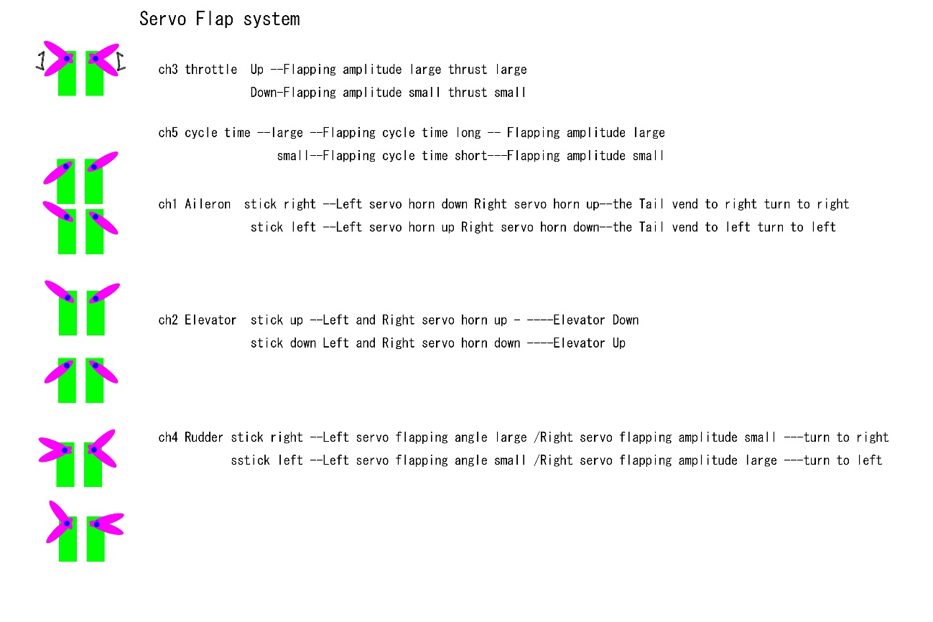

Please look Video of Youtube ---

ServoFlapOrnithopterAmericanKestrel86-3-2＆3 : Servo motion Test

<https://www.youtube.com/watch?v=6pvaHyCRNxU>

ServoFlapOrnithopter86-3-1&2＆3 : Dance of Three SFO86-3 on “One” by Peanuts Jam

<https://www.youtube.com/watch?v=hJ_FGvZynGw>

SFO86-3-3 1st Test Flight

<https://www.youtube.com/watch?v=vfHmHvgCPDU>

SFO86-3-2 1st Test Flight

<https://www.youtube.com/watch?v=Twz4DYKwONE>

1 Bilateral Servo Flap between Max high point and Max low point  
- change max flap point (throttle stick) and change Flapping frequency(5ch)  
3 Change center of Flapping angle Horizontal (Ch1 aileron stick) and Vertical (Ch2 elevator stick)  
4 Change flapping amplitude on each Servo (Ch4 rudder stick)  
Increase flap amplitude of one servo and decrease flap amplitude of another servo  
Setting : Set elevator and rudder and aileron stick Center-- 1500microsesond  
Set 5Ch at Volume or Slider or other switch

PPM Receiver-- RX PPM signal input to D2 pin  
Servo right --D5 pin  
Servo left --D6 pin

2022/04/23　Changing of Wiring for 5V RX（PPM）

Wire 5V power supply from Pro Mini Board VCC to 5V RX（PPM）

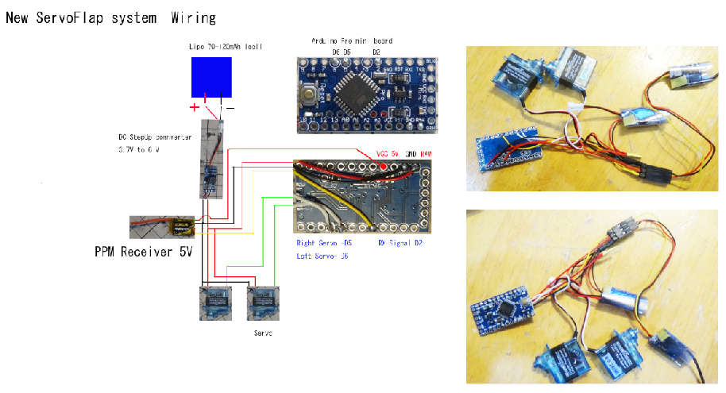  
Ground -GND pin  
6V -RAW pin ( 6-6.2V from Step down DC converter or Step up DC converter ) -for 6V servo

My setting  
Lipo: 70-120mAh1cell Lipo battery  
Servo: BLUEARROW AF D43S-6.0-MG Micro Metal Gear Digital Servo

<https://www.aliexpress.com/item/33033558575.html?spm=a2g0s.9042311.0.0.43364c4d6lqbJw>

<https://jp.banggood.com/BLUEARROW-AF-D43S-6_0-MG-Micro-Metal-Gear-Digital-Servo-For-XK-K130-RC-Helicopter-p-1509395.html?rmmds=myorder&cur_warehouse=CN>

# Servo Horn：Bluearraow Metal V950 D05023MG / K130 D03018MG Servo Swing Arm Parts For Wltoys XK K130 V950 6CH RC Helicopter

<https://www.aliexpress.com/item/4001120547325.html?spm=a2g0s.9042311.0.0.43364c4d6lqbJw>

Arduino Pro mini board  
DC stepup converter from 1cell Lipo 3.7V to 6V output

----7W mini Step-up Converter 3.7V to 6V

<https://www.aliexpress.com/item/1005001419105670.html?spm=a2g0s.9042311.0.0.27424c4dTyeLKp>

<https://jp.banggood.com/7W-Mini-DC-DC-Boost-Step-Up-Converter-2_6-5_5V-to-5V-6V-9V-12V-Voltage-Regulator-Module-p-1626160.html?rmmds=myorder&cur_warehouse=CN&ID=519957>

PPM receiver: under 2g (Smaller RX is better)

OrangeRx R616XN DSM2 / DSMX 6CH CPPM

<https://hobbyking.com/jp_jp/orangerx-r616xn-dsm2-dsmx-compatible-6ch-cppm-nano-receiver-with-failsafe.html>

On this RX

Transmitter Setting 　Endpoint

Aileron +-100% Elevator +-100% Throttle +-123%

Rudder +-70%(Smaller is better)

# FS-RX2A pro v1 2.4g 10ch ibus ppm afhds 2a flysky

<https://ja.aliexpress.com/item/1005002954612657.html?spm=a2g0o.productlist.0.0.23443335KFji3j&algo_pvid=4d1462c8-953f-4815-bb81-8dcc7f45ab2b&algo_exp_id=4d1462c8-953f-4815-bb81-8dcc7f45ab2b-9&pdp_ext_f=%7B%22sku_id%22%3A%2212000022943448015%22%7D&pdp_pi=-1%3B1598.0%3B-1%3B-1%40salePrice%3BJPY%3Bsearch-mainSearch>

On this RX

Transmitter Setting 　 Endpoint

Aileron +-100% Elevator +-100% Throttle +75 -98%

Rudder +-70%(Smaller is better)

**If abnormal behavior occurs at maximum or minimum output, decrease EndPoint until the abnormal behavior disappears and it works well.**

Arduino code is here:

<http://kakutaclinic.life.coocan.jp/SFOsys2S.html>

Flight

1) Set the throttle lever to the bottom

2) Connect Lipo battery then the wings of SFO86-2&3 spread out

3) Adjust the angle of the tail and/or CG position for gliding

This is adjusted according to flight conditions.

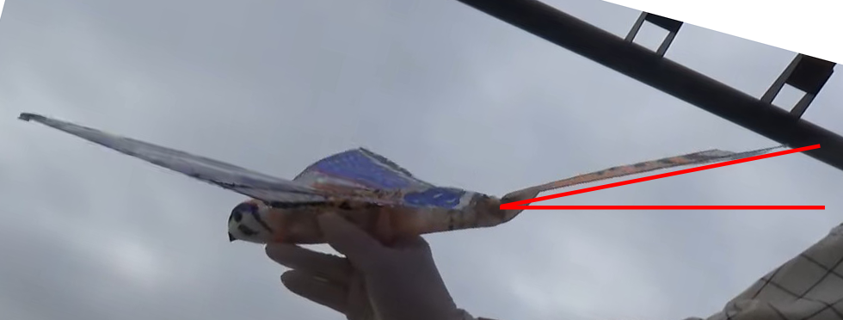

And

Set the dihedral angle.

This is adjusted according to flight conditions.

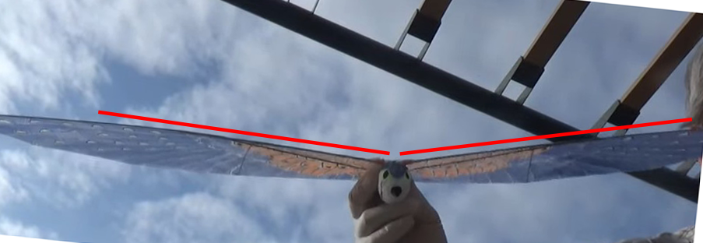

4) Adjust the flapping frequency with Ch5

　　　You need to watch the flight video of SFO86-2&3

and find the right flapping frequency.

SFO86-3-3

<https://www.youtube.com/watch?v=vfHmHvgCPDU>

SFO86-3-2

<https://www.youtube.com/watch?v=Twz4DYKwONE>

5)Adjust Aileron(Ch1) subtrim of the transmitter so that SFO86-2&3 flies straight when gliding.

Basically, you can fly smoothly by changing direction with Rudder rather than changing direction with Ailron.

When Rudder is not effective, reduce the number of flapping during flight (reduce the throttle) to improve it.

Flap wings ----Go Flight!!

Repeat the adjustment until it flies well.

* Repair of Carbon rod

